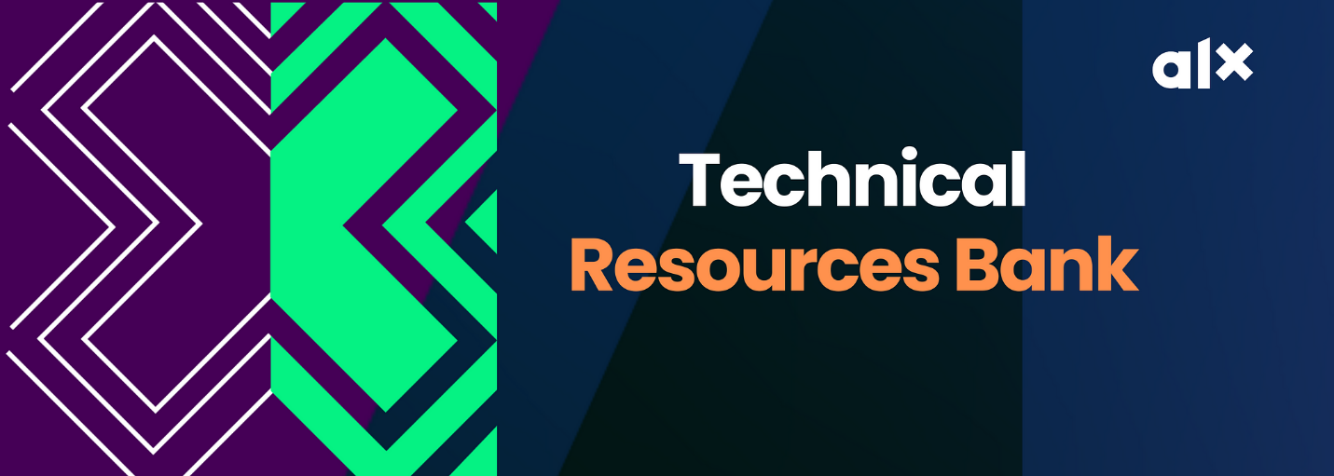

Here you’ll find all the additional learning materials, and updates from your Technical Mentors  
  
**AWS CHEAT SHEET**  
<https://tutorialsdojo.com/aws-cheat-sheets/>  
  
**AWS CLOUD ADOPTION FRAMEWORK (AWS CAF)**

**WEEK 1 (INTRODUCTION, CLOUD CONCEPTS OVERVIEW)**

Intro To Cloud Computing - <https://www.youtube.com/watch?v=M988_fsOSWo> <https://www.youtube.com/watch?v=mxT233EdY5c> <https://www.freecodecamp.org/news/what-is-cloud-computing-beginners-guide/>  
  
**Who Is an AWS Cloud Engineer** <https://oxla.io/cloud-engineer-all-you-need-to-know/>   
Do well to use it as a reference material along with your Canvas classes. Feel free to reach out if you have any clarifications to make.

**##########################################################**

**WEEK 2 (Cloud Economics and Billing, AWS Global Infrastructure Overview, AWS Cloud Security)**  
  
**AWS Service** - AWS official service catalogue   
<https://oxla.io/quick-overview-of-the-most-essential-aws-services/> <https://leanylabs.com/blog/aws-overview/>   
  
**AWS Shared Responsibility**   
<https://www.w3schools.com/aws/aws_cloudessentials_sec_sharedresponsibilitymodel.php>   
  
**AWS Global Infrastructure Map:**   
<https://aws.amazon.com/about-aws/global-infrastructure/#AWS_Global_Infrastructure_Map>   
<https://quizlet.com/297715421/aws-global-infrastructure-flash-cards/>   
  
  
**AWS BILLING**   
<https://docs.aws.amazon.com/awsaccountbilling/latest/aboutv2/billing-what-is.html> <https://www.youtube.com/watch?v=PqFW0ZkOPMM>  
  
**AWS IAM Security**   
Find it here

<https://youtu.be/SOTamWNgDKc>   
  
**##############################################################**  
  
**WEEK 3 (Networking and Content Delivery, Compute, Storage)**  
  
**Intro to VPC**   
<https://www.youtube.com/watch?v=7_NNlnH7sAg>   
<https://www.youtube.com/watch?v=bGDMeD6kOz0>   
<https://www.youtube.com/watch?v=g2JOHLHh4rI>  
<https://www.youtube.com/watch?v=l5qUSj1316M>  
<https://www.youtube.com/watch?v=w6A06U13KzU>  
  
**Intro to Basic Computer Networking**   
<https://www.youtube.com/watch?v=_IOZ8_cPgu8>   
<https://www.youtube.com/watch?v=E5bSumTAHZE>  
<https://oxla.io/computer-networking-9-interesting-things-you-should-know/>  
  
**AWS EC2**   
<https://www.youtube.com/watch?v=TsRBftzZsQo>   
<https://www.youtube.com/watch?v=-L6g9J9_zB8>   
  
**AWS S3**   
<https://www.youtube.com/watch?v=mDRoyPFJvlU>   
  
**Documentations**   
**Amazon VPC Overview page:** <https://docs.aws.amazon.com/vpc/latest/userguide/what-is-amazon-vpc.html>  
  
**Amazon** **Virtual Private Cloud Connectivity Options whitepaper:** <https://docs.aws.amazon.com/whitepapers/latest/aws-vpc-connectivity-options/introduction.htm>  
  
**Confused by AWS Storage Options? S3, EFS, EBS Explained:**

**###########################################################**

**WEEK 4 (Databases, Cloud Architecture, Auto Scaling and Monitoring)**  
  
**Databases (RDS, Aurora and Dynamo DB)**

<https://www.w3schools.com/whatis/whatis_aws_rds.asp>

[https://k21academy.com/amazon-web-services/aws-solutions-architect/amazon-rds](https://k21academy.com/amazon-web-services/aws-solutions-architect/amazon-rds/)/

<https://explore.skillbuilder.aws/learn/course/external/view/elearning/61/aws-database-offerings>

<https://explore.skillbuilder.aws/learn/course/external/view/elearning/86/amazon-aurora-mysql-basics>

<https://explore.skillbuilder.aws/learn/course/external/view/elearning/65/introduction-to-database-migration>

[https://explore.skillbuilder.aws/learn/course/external/view/elearning/326/amazon-dynamodb-service-introductio](https://explore.skillbuilder.aws/learn/course/external/view/elearning/326/amazon-dynamodb-service-introduction)n

**Well Architected Framework** - [https://docs.aws.amazon.com/wellarchitected/latest/framework/welcome.htm](https://docs.aws.amazon.com/wellarchitected/latest/framework/welcome.html)l [https://aws.amazon.com/blogs/apn/the-6-pillars-of-the-aws-well-architected-framework](https://aws.amazon.com/blogs/apn/the-6-pillars-of-the-aws-well-architected-framework/)/

**AWS AutoScaling** - [https://aws.amazon.com/autoscaling/getting-started](https://aws.amazon.com/autoscaling/getting-started/)/ [https://tutorialsdojo.com/aws-auto-scaling](https://tutorialsdojo.com/aws-auto-scaling/)/

**AWS Trusted Advisor** -<https://docs.aws.amazon.com/awssupport/latest/user/trusted-advisor.html>

**AWS AI/ML SERVICES**  
<https://duplocloud.com/blog/aws-ai-ml-services/>  
  
**PRACTICE QUESTIONS**  
All the practice questions in the list below are FREE. So, kindly make good us of them.

[https://digitalcloud.training/courses/free-aws-certified-cloud-practitioner-practice-exam](https://digitalcloud.training/courses/free-aws-certified-cloud-practitioner-practice-exam/)/

[https://www.whizlabs.com/blog/aws-cloud-practitioner-certification-questions](https://www.whizlabs.com/blog/aws-cloud-practitioner-certification-questions/)/

[https://www.examtopics.com/exams/amazon/aws-certified-cloud-practitioner](https://www.examtopics.com/exams/amazon/aws-certified-cloud-practitioner/)/

[https://portal.tutorialsdojo.com/courses/free-aws-certified-cloud-practitioner-practice-exams-sampler](https://portal.tutorialsdojo.com/courses/free-aws-certified-cloud-practitioner-practice-exams-sampler/)  
  
<https://learn.digitalcloud.training/course/free-aws-certified-cloud-practitioner-practice-exam?/>  
  
<https://www.whizlabs.com/blog/aws-cloud-practitioner-certification-questions/>   
  
<https://www.examtopics.com/exams/amazon/aws-certified-cloud-practitioner/>   
  
<https://portal.tutorialsdojo.com/courses/free-aws-certified-cloud-practitioner-practice-exams-sampler/>   
  
<https://medium.com/geekculture/aws-certified-cloud-practitioner-practice-exam-questions-8c7da4d759af>   
  
<https://passemall.com/free-aws-cloud-practitioner-practice-exam>   
  
<https://www.itexams.com/exam/AWS-Certified-Cloud-Practitioner> <https://free-braindumps.com/amazon/free-aws-certified-cloud-practitioner-braindumps.html>

**YouTube Practice Questions (Make sure to watch at least 50% of the below videos before attempting the exam)**  
<https://www.youtube.com/watch?v=mLs3cxbLWos&list=PL7GozF-qZ4KeQftuqU3yxvQ-f3eFNUiuJ>  
  
###########################################################  
**AI & ML SERVICES**

Go To Youtube or ALX Learning Resources

###########################################################  
**AWS CLOUD ADOPTION FRAMEWORK**  
If you ever come across the AWS Cloud Adoption Framework in the CCP Practice questions, do not panic. Here is all you need to know about it for the CCP, and sample questions you may encounter in the exam.

Go To Youtube or ALX Learning Resources

AWS Cloud Adoption Framework are set of practices that AWS put together to make a business’s move to use cloud computing technology much seamless.

They are guides that contains key considerations that an AWS customer needs to consider before migrating their workload to the cloud. The guide includes - involvement level of all the stakeholders in the business’ operations, the flow of communication between the units in the organization, examining factors that ensure that the business is ready to adopt the cloud model of operating, the transitioning method, etc.

According to AWS, there are 6 key perspective when it comes to Cloud Adoption or transitioning. They include:

* [Business](https://docs.aws.amazon.com/whitepapers/latest/overview-aws-cloud-adoption-framework/business-perspective.html)
* [People](https://docs.aws.amazon.com/whitepapers/latest/overview-aws-cloud-adoption-framework/people-perspective.html)
* [Governance](https://docs.aws.amazon.com/whitepapers/latest/overview-aws-cloud-adoption-framework/governance-perspective.html)
* [Platform](https://docs.aws.amazon.com/whitepapers/latest/overview-aws-cloud-adoption-framework/platform-perspective.html)
* [Security](https://docs.aws.amazon.com/whitepapers/latest/overview-aws-cloud-adoption-framework/security-perspective.html)
* [Operations](https://docs.aws.amazon.com/whitepapers/latest/overview-aws-cloud-adoption-framework/operations-perspective.html)